A Project Report on
Online Food Ordering System
Submitted in partial fulfilment of the requirements for the award of the degree of
Bachelor of Technology
in
Electronics And communication Engineering

By
PUTTAMANENI SWARNA 24KB1A04U4
GIDDALURU RAMYAMAHALAKSHMI 24KB1A04A3
THODAPU SUCHARITHA 24KB1A04AD
VALIPI PRAVALLIKA 24KB1A04AV
PATHAN SALMA 24KB1A04S0

Under the Esteemed Supervision of
Mr. A.V.V. Satish, Trainer, Bytexl  

Department of Electronics and Communication Engineering
NBKR INSTITUTE OF SCIENCE AND TECHNOLOGY
(An Autonomous Institution)
VIDYANAGAR – 524 413, TIRUPATI DIST, AP

Bonafide certificate

This is to certify that the mobile application entitled “Online Food Ordering System” is a bonafide work done by Ms. P. Swarna (24KB1A04U4), Ms. G. Ramyamahalakshmi (24KB1A04A3), Ms. T. Sucharitha (24KB1A04AD), Ms. V. Pravallika (24KB1A04AV),
Ms. P. Salma (24KB1A04S0) in the department of Electronics & Communication Engineering, N.B.K.R. Institute of Science & Technology, Vidyanagar and is submitted to JNTUA, Ananthapuramu in the partial fulfilment for the award of B.Tech degree in Electronics & Communication Engineering. This work has been carried out under my supervision.

Dr.C. Ravindra Reddy
Professor&HOD
Dept. Of. ECE
N.B.K.I.S.T

DECLARATION
I hereby declare that the project entitled “Online Food Ordering System” is an original work carried out by me as part of my academic curriculum. The program has been developed using the c programming language, and the source code is written and tested by me.
This project simulates a simple console-based food ordering system, allowing users to select items from a menu, enter the quantity, and compute the total bill based on item prices. The system includes basic functionalities such as user input, decision-making using switch statements, looping using do-while, and handing invalid inputs gracefully.
This project aims to develop a user-friendly, efficient, and functional online food ordering system using the C programming language. The system is designed to manage orders, display menus, calculate bills, and store customer details efficiently. The documentation includes various phases of development such as system analysis, design, implementation, testing, and conclusion.

I have taken due care to acknowledge all sources of information and assistance, and I affirm that the work is original and has not been copied or submitted elsewhere for any academic or professional purpose.

This project has been completed as part of my academic requirement and reflects my individual efforts and understanding of software development principles, particularly in the area of procedural programming and system design. This project aims to develop a user-friendly, efficient, and functional online food ordering system using the C programming language. The system is designed to manage orders, display menus, calculate bills, and store customer details efficiently. The documentation includes various phases of development such as system analysis, design, implementation, testing, and conclusion.

ACKNOWLEDGEMENT
The satisfaction that accompanies the successful mobile application would be in
complete without the people who made it possible of their constant guidance and
encouragement crowned our efforts with success.
We would like to express our profound sense of gratitude to our mobile application
guide Ms. Sravani, Assistant Professor, Department of ECE, N.B.K.R.I.S.T (affiliated to JNTUA, Anantharamu), Vidyanagar, for his masterful
guidance and the constant encouragement throughout the web application. Our sincere thanks for his suggestions and unmatched services without, which this work would have been an unfulfilled dream.
We convey our special thanks to Sri N. Ram Kumar Reddy, respectable
correspondent of N.B.K.R. Institute of Science and Technology, for providing excellent infrastructure in our campus for the completion of the mobile application.
We are grateful to Sri Dr. Vijaya Kumar Reddy, Director, of N.B.K.R Institute of Science and Technology for allowing us to avail all the facilities in the college.
We express our sincere gratitude Dr. Ravindra Reddy, Professor, Head of Department ECE for providing exceptional facilities for successful completion of our mobile application.
We would like to convey our heartful thanks to Staff members, Lab technicians, and our friends, who extended their cooperation in making this mobile application as a successful one.
We would like to thank one and all who have helped us directly and indirectly to
complete this mobile application success.
Index
SNO CHAPTER NAME PAGE NUMBERS
- Introduction 1-5
- Requirement analysis 6-12
- Tools &Technologies 13-16
- Working mechanism 17-18
5. Modules 19-20
6. System Design 21-22
7. System Implementation 23-24
8. code output 25
9. Conclusion 26

1. Introduction 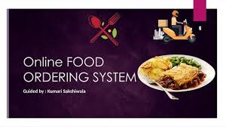
In the current digital age, automation and convenience have become central to modern living. One of the many services embracing this transition is the food industry. This project presents an online food ordering system developed using the C programming language. The program is a console-based application that allows users to order various food items, choose quantities, and get the final billing amount instantly. It represents a simplified simulation of how an actual online food ordering platform works at the backend.
The main objective of this system is to:
Provide a menu to the.
Accept food item selections.
Handle multiple orders.
Display the total bill based on item prices and quantities.
This system is user-friendly and can be further enhanced into a GUI or integrated with databases for practical use in restaurants or food delivery startups.
An online food ordering system is a digital platform that allows customers to browse restaurant menus, place orders, and pay for their food online, either through a website or a mobile application. This system streamlines the traditional food ordering process, offering convenience to both customers and restaurants.
How it Works:
Menu Browsing: Customers can view digital menus with detailed descriptions, images, prices, and customization options.
Order Placement: Customers select their desired items, specify quantities, add special instructions, and add them to a virtual cart.
Checkout and Payment: Once done, they proceed to checkout, review their order, and choose from various online payment methods (credit/debit cards, digital wallets, etc.). Some systems also offer a cash-on-delivery option.
Order Confirmation: After successful payment, customers receive an order confirmation with details and estimated delivery/pickup time.
Restaurant Processing: The restaurant receives the order through their system, which could be integrated with their Point of Sale (POS) system, and begins preparing the food.
Delivery/Pickup: Customers can choose to have their food delivered to their specified address or pick it up themselves from the restaurant. Real-time order tracking is often available for delivery orders.
Benefits for Customers:
Convenience: Order from anywhere, anytime using a computer or smartphone.
Wider Choices: Access menus from a variety of restaurants in one place.
Easy Customization: Modify orders according to preferences or dietary needs.
Multiple Payment Options: Pay securely using various digital methods.
Order Tracking: Monitor the progress of their delivery in real-time.
Reviews and Ratings: Make informed decisions based on other customers' experiences.
Benefits for Restaurants:
Expanded Reach: Access a larger customer base beyond their physical location.
Increased Efficiency: Automate the order-taking process, reducing errors and freeing up staff.
Improved Order Accuracy: Digital orders minimize misunderstandings common with phone orders.
Data Collection and Analytics: Gather valuable insights into customer preferences and ordering patterns.
Marketing Opportunities: Promote specials, discounts, and loyalty programs through the platform.
Streamlined Operations: Integrate with POS and kitchen systems for smoother workflow.
Enhanced Customer Experience: Provide a modern and convenient ordering option.
In essence, online food ordering systems have revolutionized how people order and receive food, offering a more efficient, convenient, and transparent experience for everyone involved in the food service industry

2 .Requirement Analysis
Requirement analysis is the process of identifying the expectations and needs of stakeholders for a system. For an Online Food Ordering System, the requirement analysis is divided into two main categories: Functional Requirements and Non-Functional Requirements.
1. Functional Requirements
These define what the system should do:
User Registration and Login:
Users can register and log in using email and password.
Admin and customer roles are differentiated.
Browse Menu:
Customers can view the list of available food items with details (name, price, category, etc.).
Place Orders:
Customers can select food items, add them to cart, and place orders.
Payment System
Users can pay online via payment gateways or choose cash on delivery.
Order Management:
Customers can view order history and track current orders.
Admin can manage (view, update, cancel) all orders.
Menu Management (Admin):
Admin can add, update, or delete menu items.
Customer Support:
System provides help or contact option for queries.
2. Non-Functional Requirements
These define system properties and constraints: performance:
System should handle multiple users simultaneously with minimal delay.
Scalability:
Should support addition of more restaurants, users, or menu items in the future.
Security:
Passwords must be encrypted, and sensitive data should be protected.
Secure payment processing.
Availability:
The system should be available 24/7 with minimal downtime.
Usability:
Interface must be user-friendly and accessible to both technical and non-technical users.
Maintainability:
System code and architecture should be easy to update and maintain.
Advantages of an online food ordering system:
1. convenience: Customers can place orders anytime and from anywhere using a smartphone or computer.
2. Time-Saving: Reduces the time spent on ordering compared to phone calls or in-person visits.
3. Order Accuracy: Minimizes human errors, as customers input their orders directly.
4. 24/7 Availability: Orders can be placed even outside of regular business hours (if enabled).
5. Enhanced Customer Experience: Users can view menus, prices, and reviews before ordering.
6. Increased Efficiency: Automates order management, reducing staff workload and speeding up service.
7. Real-Time Tracking: Customers can track the status of their orders and delivery progress.
8. Better Data Management: Helps store customer data, order history, and analytics for business improvement.
9. Marketing Opportunities: Enables targeted promotions, discounts, and loyalty programs.
10. Higher Sales Potential: Attracts more customers and can increase order frequency and average order value.
Disadvantages of an online food ordering system:
1. Technical Issues: System crashes, slow internet connections, or app bugs can disrupt orders or delay confirmations.
2. Delivery Delays: Food delivery may be delayed due to traffic, high demand, or poor logistics, impacting customer satisfaction.
3. Food Quality Concerns: Food may arrive cold, spilled, or not as fresh as expected, affecting the overall experience.
4. Lack of Personal Interaction: Customers can’t clarify preferences or ask specific questions as easily as with in-person ordering.
5. Hidden Costs: Additional fees such as delivery charges, service fees, and tips may increase the total bill unexpectedly.
6. Data Security Risks: Online systems may store sensitive customer data, which can be targeted in counterattacks if not properly secured.
7. Dependency on Technology: Restaurants and users become heavily reliant on digital systems, which can cause issues during outages or maintenance.
8. Miscommunication: Automated systems may misinterpret customizations or special instructio
3.Tools
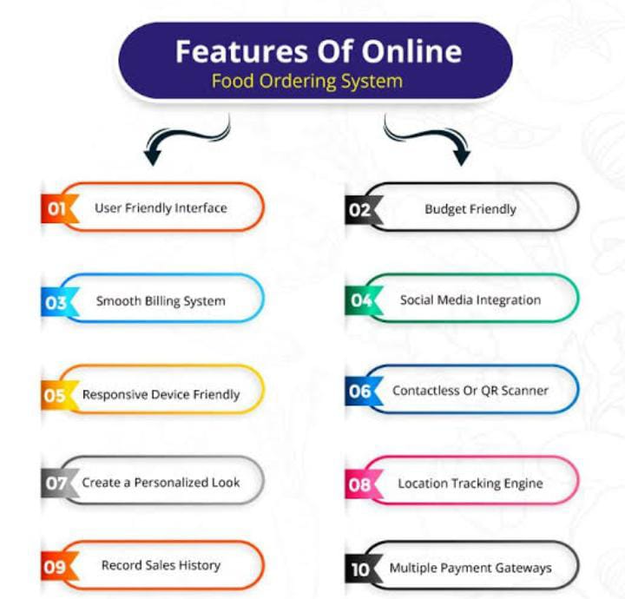
1. Online Ordering Software: Custom-built solutions or third-party software like Up serve, Toast, or Light speed.
2. Food Delivery Platforms: Companies like Uber Eats, DoorDash, Grubhub, or Foodpanda.
3. Restaurant Management Systems: Integrated systems like Square, Aloha, or Restaurant365.
4. Payment Gateways: Secure payment processing solutions like Stripe, PayPal, or Square.
5. Mobile Apps: Native apps for iOS and Android, or cross-platform apps built using frameworks like React Native.
6. Website Builders: Platforms like WordPress, Wis, or Square space for creating online ordering websites.
7. API Integration: Integrating with third-party services for features like mapping, notifications, or customer loyalty programs.
Features
1. Menu management
2. Order management
3. Payment processing
4. Delivery integration
5. Customer management
6. Reporting and analytic
7. Integration with social media and review platforms
Benefits
1. Streamlined ordering process
2. Increased customer reach
3. Improved operational efficiency
4. Enhanced customer experience
5. Data-driven insights for business decision
These tools and platforms help restaurants and food businesses manage their online presence, streamline operations, and provide a seamless customer experience.
Technologies
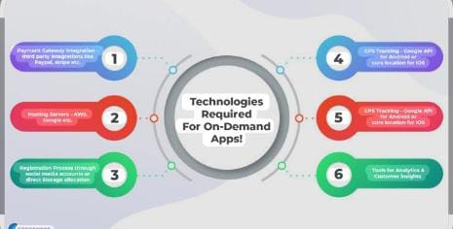
Front-end technologies
1. HTML/CSS/JavaScript: For building responsive and user-friendly interfaces.
2. React, Angular, or Vue .js: Popular front-end frameworks for building dynamic web applications.
3. Mobile App Development: Native or cross-platform apps for iOS and Android.
Back-end Technologies
1. Server-side Languages: Node.s, Python, Ruby, or PHP for handling requests and responses.
2. Database Management: Relational databases like MySQL or PostgreSQL, or NoSQL databases like MongoDB.
3. API Design: Restful API or Graph for integrating with front-end applications.
Payment and Integration Technologies
1. Payment Gateways: Secure payment processing solutions like Stripe, PayPal, or Square.
2. API Integration: Integrating with third-party services for features like mapping, notifications, or customer loyalty programs.
Other Technologies
1. Cloud Computing: Scalable infrastructure for handling high traffic and large datasets.
2. Artificial Intelligence (AI): For personalization, recommendation engines, or catboats.
3. Data Analytic: For insights into customer behavior, sales trends, and operational efficiency.
These technologies work together to provide a seamless online food ordering experience for customers and efficient operations for restaurants.
4.Working mechanism
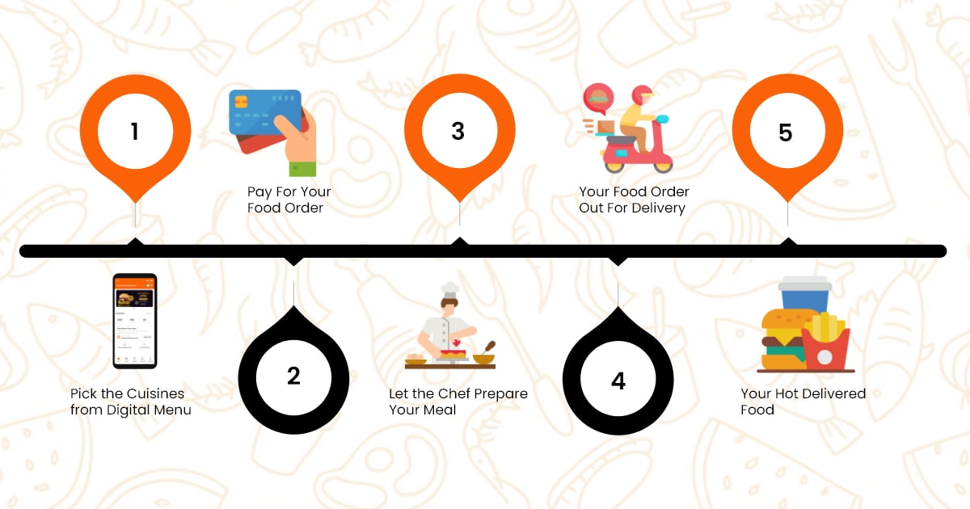
An online food ordering system involves several components that interact to allow users to browse food items, place orders, and receive deliveries. Here's a structured breakdown of how it works:
1. User Interface (Front-End)
user Registration/Login: Users create accounts or log in.
Browse Menu: Users view available restaurants and food items.
Cart System: Users add items to a virtual cart.
Order Placement: Users confirm the cart, choose payment and delivery options.
2. Back-end Processing
Order Management: The system receives and logs the order details.
Database Interaction: Retrieves and updates:
User details
Menu items
Order status
Payment Gateway Integration: For online payments via card, wallet, or UPI.
Inventory Management: (Optional) Updates stock levels for restaurants.
3. Restaurant Interaction
Order Notification: Restaurants get notified of new orders.
Order Preparation: Food is prepared based on received details.
Order Confirmation: Restaurant updates order status in the system. 4. Delivery Mechanism
Delivery Assignment: The system assigns a delivery person.
Tracking: Users can track the delivery in real-time (if supported).
Order Delivery: Delivery agent delivers the food to the user's address.
5. Post-Order Features
Feedback and Rating: Users rate the food and delivery.
Order History: Users can view past orders.
Notifications: Via SMS, email, or app for promotions or order updates.

5. Modules

The project is broken down into the following modules for better understanding and modular design:
2.1. Menu Display Module
This module displays the available food items and their prices. It uses printf() statements to show the menu.
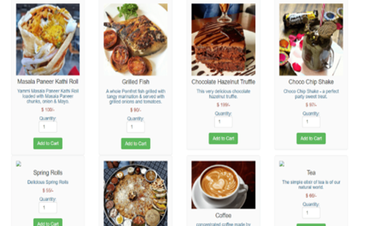
2.2. Input Module
Handles user input for selecting food items and entering quantity. It uses scanf() to read numeric and character inputs from the user.
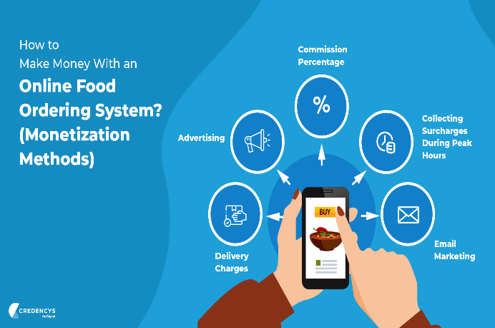
2.3. Order Processing Module
This module contains the logic to calculate the total bill based on user choices. It uses a switch-case block to apply the appropriate pricing logic.
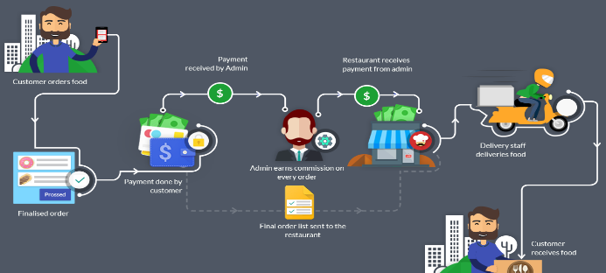
2.4. Control Flow Module
Utilizes a do-while loop to enable continuous ordering until the user decides to exit. Also includes input validation.

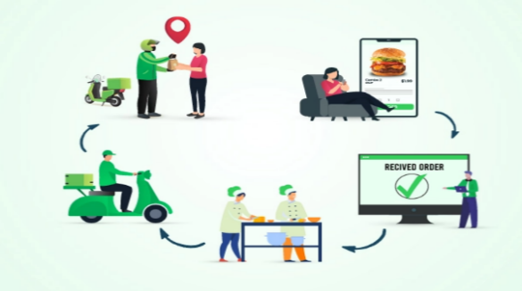

2.5. Exit and Billing Module
Displays the total bill and thanks the user for using the service. This is executed after the user decides to stop ordering.
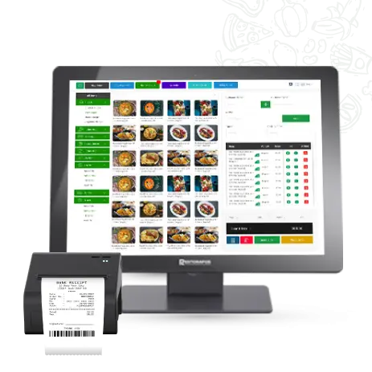

6. System Design

3.1. Architecture
This system follows a linear, procedural architecture where control flows sequentially from displaying the menu to exiting the program. The system design is created in this phase after studying the requirement specifications from the first phase. This system design aids in determining the overall system architecture as well as the hardware and system requirements.
3.2. Flowchart

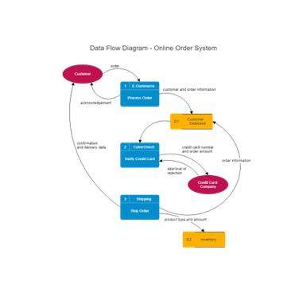

3.3. Data Handling
Uses primitive data types (int, float, char) for handling inputs and calculations.
total variable stores cumulative cost.
3.4. Error Handling
Includes basic validation to reject invalid menu options.
Prompts the user if an invalid input is given.
7. System Implementation

Below is the full implementation of the code used for the system:
#include <stdio.h>
int main() {
int choice, quantity;
float total = 0;
char orderAgain;
do {
printf("\n--- Online Food Ordering Menu ---\n");
printf("1. Burger - $5.00\n");
printf("2. Pizza - $8.00\n");
printf("3. Sandwich - $4.00\n");
printf("4. Coffee - $2.50\n");
printf("5. Exit\n");
printf("Enter your choice (1-5): ");
scanf("%d", &choice);
if (choice == 5) {
break;
}
printf("Enter quantity: ");
scanf("%d", &quantity);
switch (choice) {
case 1: total += 5.0 * quantity; break;
case 2: total += 8.0 * quantity; break;
case 3: total += 4.0 * quantity; break;
case 4: total += 2.5 * quantity; break;
default: printf("Invalid choice!\n"); break;
}
printf("Do you want to order more? (y/n): ");
scanf(" %c", &order Again);
} while (order Again == 'y' || order Again == 'Y');
Printf ("\nThank you for your order!\n");
printf ("Total bill: $%.2f\n", total);
return 0;
}

8.Code Output

Sample Output 1:
--- Online Food Ordering Menu ---
1. Burger - $5.00
2. Pizza - $8.00
3. Sandwich - $4.00
4. Coffee - $2.50
5. Exit
Enter your choice (1-5): 2
Enter quantity: 2
Do you want to order more? (y/n): y
Total bill: $16.00
Sample Output 2 (Invalid choice):
Enter your choice (1-5): 7
Invalid
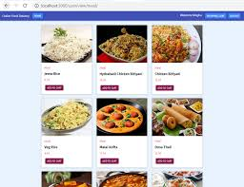

9.Conclusion
This online food ordering system offers a basic but functional approach to understanding user interaction, control structures, and simple billing logic in C programming. While it operates via a command-line interface, it lays the groundwork for more complex systems involving file storage, database integration, and UI/UX design.
This project can be enhanced by:
Adding user login and registration features.
Storing orders in a file.
Allowing item customization.
Using functions to modularize code.
Extending to GUI using tools like GTK or Win API.

Thank You

